EXPERIMENT- 6
Q] Write a python program for Vacuum Cleaner problem.
Aim-
To implement the Vacuum Cleaner Problem using a Simple Reflex Agent that cleans all dirty rooms.
Algorithm-
- Initialize two rooms (A and B) with their status (Clean/Dirty).
- Place the vacuum cleaner in the starting room.
- Check the current room.
- If the room is dirty, clean it.
- Move to the next room.
- Repeat until both rooms are clean.
- Display the final status of all rooms.
Program-
rooms = { "A": "Dirty", "B": "Dirty"}
position = "A"
print("Initial Room Status:")
print(rooms)
print()
while True:
print("Vacuum is in Room", position)
if rooms[position] == "Dirty":
print("Room", position, "is Dirty")
print("Cleaning Room", position)
rooms[position] = "Clean"
else:
print("Room", position, "is already Clean")
if position == "A":
position = "B"
else:
position = "A"
if rooms["A"] == "Clean" and rooms["B"] == "Clean":
break
print("\nFinal Room Status:")
print(rooms)
print("\nAll rooms are Clean.")
Sample Input-
Room A = Dirty
Room B = Dirty
Initial Position = Room A
Sample Output-
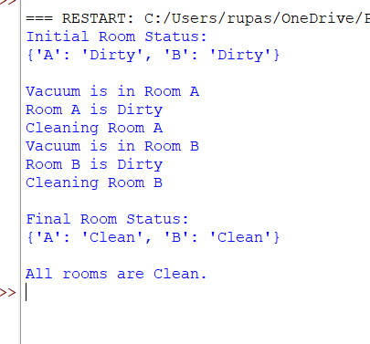
Result-
The Missionaries and Cannibals Problem was solved successfully using the Breadth First Search (BFS) algorithm, and all missionaries and cannibals were transported safely across the river without violating the problem constraints.

